# Chapter 6: Design

## Chapter Overview

In this chapter, the class diagram, activity diagram and sequence diagram of the proposed solution will be elaborated and visually represented. Also an overview of all the diagrams will be elaborated at the end of this chapter.

## Class Diagram

Class diagram below represents the attributes and methods of each class in the proposed raster to vector conversion platform. Each class’s relationship with each other is also shown and also aggregation/composition relationships.

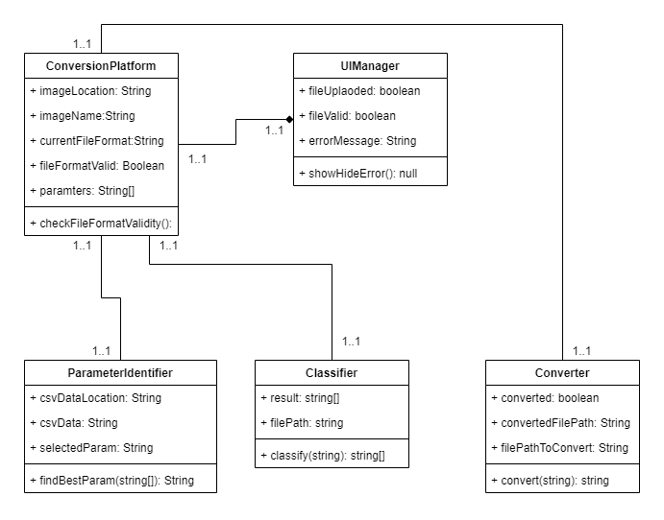

## Activity Diagram

The flow of activities in the Raster to Vector conversion platform is shown by the activity diagram shown below. This diagram is created according to the flows that were described in the use case diagrams and descriptions. This can be identified as the successful flow of activities for converting an image from raster to vector.

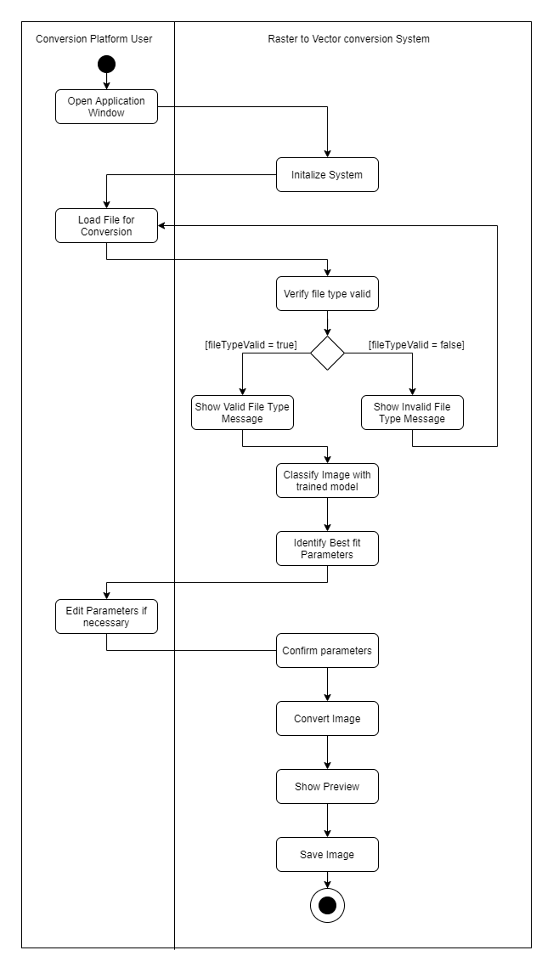

## Sequence Diagram

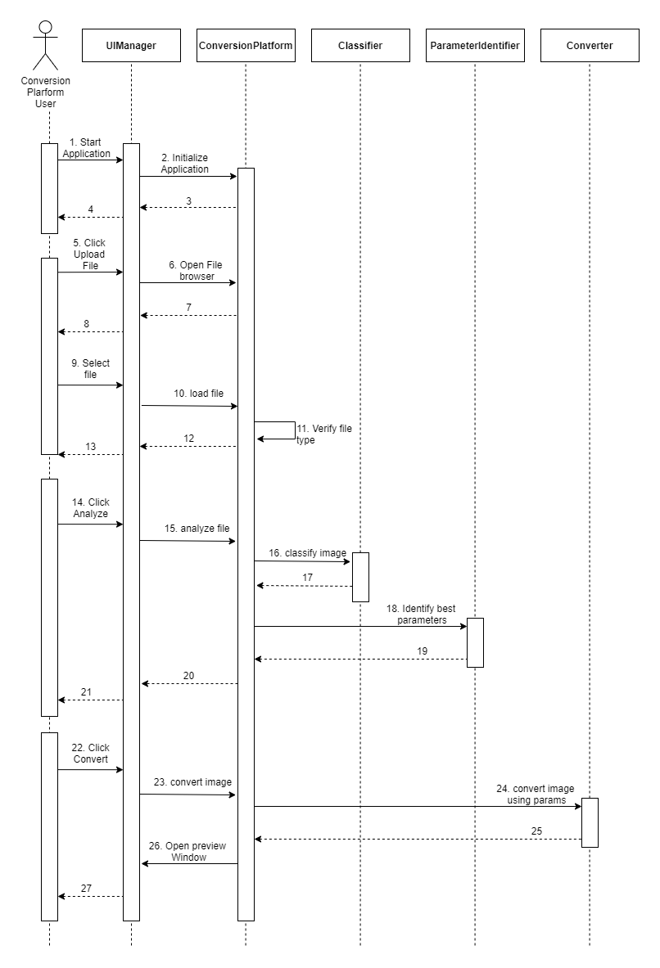

The diagram above represents how the user interacts with the raster to vector conversion platform. The user starts by opening up the application, which then initializes the conversion platform. Then the user can locate an image file that they wish to convert. Once the file is loaded. It will be verified if it is of the valid file types accepted by the system. If this is the case. The user will be allowed to analyze the file. The conversion platform then uses the image classification trained model to classify the image and get its accuracy as to which classification it belongs to. Using this information then the best fit parameters are identified. Then the user is allowed to click the convert button which then converts the image into a temporary location. The user is also showed a preview of the converted image. This can be considered the sequence followed for a successful image conversion.

## Chapter Summary

Summary